Alcohols

Alcohols can be primary, secondary or tertiary:

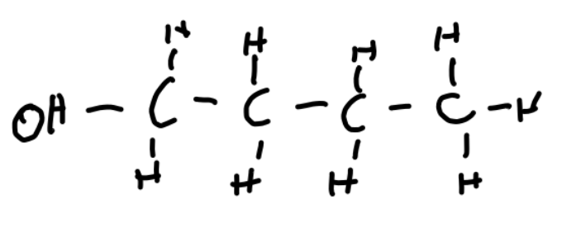
Primary:
-OH connected to a carbon with 1 carbon attached.

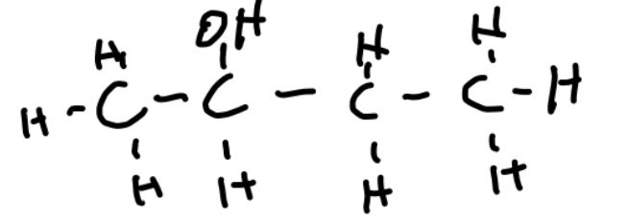
Secondary:
-OH connected to carbon with 2 carbons attached.

Tertiary:
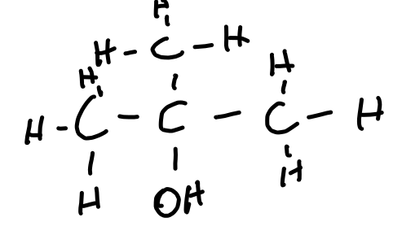
-OH connected to carbon with 3 carbons attached.

Comparison with alkanes

Alcohols have polar OH bonds. This is because of the electronegativity difference between the O and the H.

Alkanes are non-polar.

This means that alkanes experience only London forces, while alcohols can experience London forces, and the stronger dipole-dipole and hydrogen forces.

Hydrogen bonds in alcohols means alcohols are soluble in water, and alkanes are not.

Longer alcohols are less soluble, as they have more non-polar parts, as the OH group is the only polar part.
Longer alcohols have a lower boiling point and volatility, as their hydrogen bonds are less effective with the greater mass of the molecule, with the same number of OH groups.

